**Experiment No. 3.3**

**Student Name: Rishav Kumar UID: 22MCC20039**

**Branch: MCA - CCD Section/Group: MCD-1/ Grp A**

**Semester: IV Date of Performance: 17th Apr 24**

**Subject Name: CI/CD Pipelines Subject Code: 22CAP-781**

1. **Aim/Overview of the practical:**

Build maven project using build node whenever there is a push on Master Node..

1. **Code for practical:**

* Continue to the previous worksheet se can configure SCM (source code management) to plan a build on every push operation by master node in Jenkins.

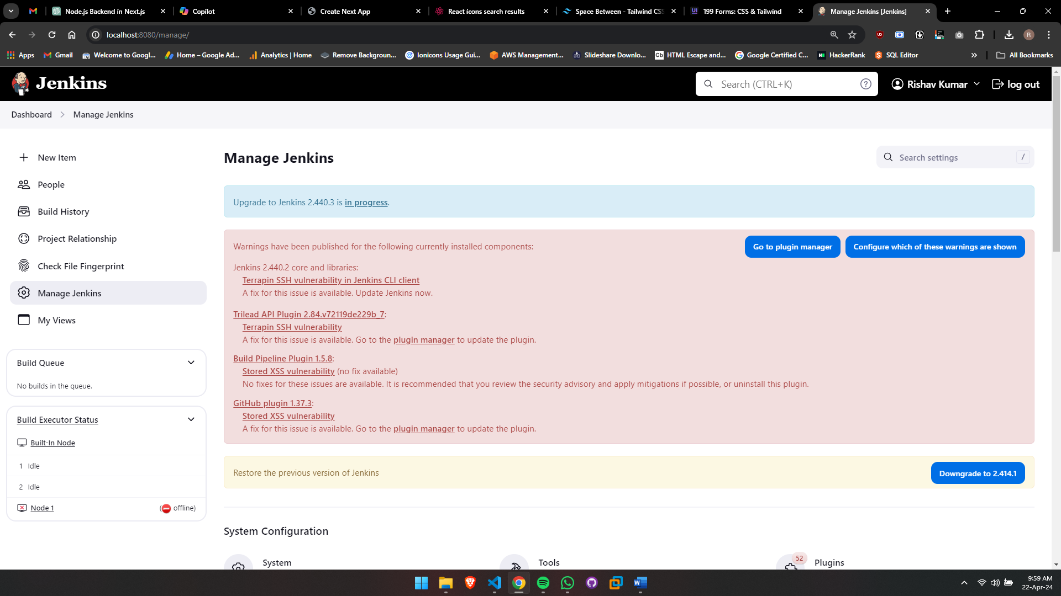

* Open SCM for configuration

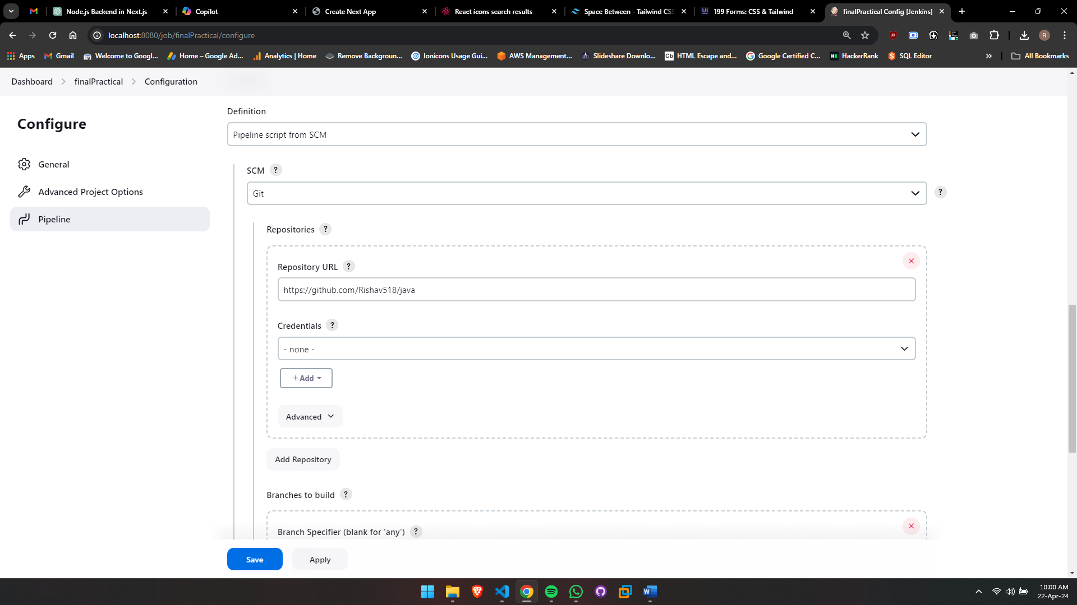

* Finally, we can see our maven project is triggered on the agent node with the specific SCM configuration on every push by Master Node.

